# ****Annual Conference of the Regional Studies Association Irish Branch****

# City-Led Regional Development and Peripheral Regions

# ****Friday 7 September 2017, Institute of Technology Sligo****

**Invited speakers:**

**Andrew Copus**

The James Hutton Institute

**Professor mark Partidge**

Ohio State University

**Other confirmed speakers:**

Helen McHenry (WDC); David Minton (NWRA); John Nugent (IDA Ireland); Justin Doran (UCC); Chris van Egeraat (MU); Proinnsias Breathnach (MU); Jim Walsh (MU); Des McCafferty (UL); Edgar Morgenroth (DCU); Nuachi Louis (DIT)

**(registration and accomodaiton details below)**

 

**Keynote Speaker Sponsored by the Western Development Commission and the Northern and Western Regional Authority**

**Andrew Copus**

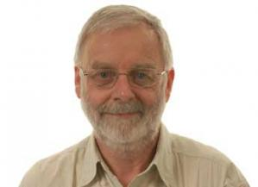Andrew Copus is an Economic Geographer in the Social Economic and Geographical Sciences (SEGS) Group at the James Hutton Institute. Between 2005 and February 2017 he was also a Senior Research Fellow at Nordregio (Nordic research centre for regional development and planning) in Stockholm. His research interests relate to changes in rural economic activity, especially in remote and sparsely populated areas, and to rural policy (broadly defined). Current research projects include Scottish Government-funded work on the future of Scotland’s Sparsely Populated Areas, and an EU-funded project (RELOCAL), on spatial justice. He has participated in a number of EU funded research projects relating to rural development, (ESPON PROFECY, ESPON TiPSE, DERREG, RuDI, TOP-MARD) and was coordinator of ESPON EDORA and AsPIRE). He has worked as a consultant for DG Regio, DG Agriculture, the European Parliament and the Joint Research Centre (Seville). He was co-author of Territorial Cohesion in Rural Europe, published by Routledge.

Mike’s paper is entitled “The Scottish City Region Deals – A rural development perspective”. Urban-rural interaction are a long-established element of the “theory of change” associated with regional development policy. Optimistic assumptions about wider functional region benefits of city investments, are commonplace and generally unquestioned, despite meagre evidence of such impacts. A summary history of urban-rural concepts in the European policy discourse, will be followed by a brief account of rural/regional policy in Scotland. Against this background the origin and evolution of Scotland’s City Region Deals, and Regional Partnerships, will be described. The presentation will conclude with some reflections on the how these evolving arrangements fit into an already cluttered policy landscape, their compatibility with rural policy “mainstreaming”, and the likely benefits for rural Scotland.

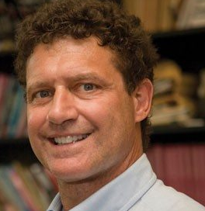**Mark Partridge**

Professor Mark Partridge is the C. William Swank Chair of Rural-Urban Policy at The Ohio State University and a Professor in the AED Economics Department. He is also an economic consultant at the Federal Reserve Bank of Chicago; Adjunct Professor at Jinan University, Guangzhou China; and Gran Sasso Science Institute, L’Aquila, Italy. Prior, he was the Canada Research Chair in the New Rural Economy at the University of Saskatchewan. Professor Partridge has published over 125 peer-reviewed journal papers. His work has been ranked number one in regional science and among the top 1000 economists in the world. He has published in many journals such as the American Economic Review, Journal of Economic Geography, Journal of International Economics, Journal of Urban Economics, Journal of Business and Economic Statistics, and Review of Economics and Statistics. He co-authored the book The Geography of American Poverty: Is there a Role for Place-Based Policy? Dr. Partridge frequently gives keynote addresses to academic and practitioner groups. He has received research funding from many sources including the Appalachian Regional Commission, Brookings Institution, European Commission, U.S. NSF, U.S. National Oceanic and Atmospheric Administration, Canadian Social Science and Humanities Research Council, USDA, and World Bank.

**Abstract**: Rural areas have received increased attention with the rise of right-wing populist parties in Western countries, in which a strong part of their support is rural based. While the underlying reasons are complex and unique to each country, one common feature is that rural areas have typically faced recent economic decline, creating anxiety, and in some cases, anger of rural residents directed at their urban counterparts. Thus, bridging this rural-urban economic divide takes on added importance in not only improving the individual livelihoods of rural residents but in increasing social cohesion. One way to bridge this economic gap is to improve rural-urban economic linkages through an urban-led economic strategy. For example, urban growth can create commuting and market opportunities for rural residents and firms if there is sufficient connectivity. While such a process has strong theoretical advantages then in trying to create growth in rural areas themselves, such a strategy requires changes in governance. It also requires rural areas to more carefully think about quality of life to attract and retain residents who would otherwise relocate to urban areas.

**Registration**   
Register for the conference online at:

<http://rsa-ireland.weebly.com/register.html>   
  
Please note that there is a €70 fee for attending the conference and this includes lunch. Payments are processed via PayPal.

**Conference updates**

Updates on the conference will be available on the RSA-Irish Branch website at <http://rsa-ireland.weebly.com> It is encouraged to subscribe to the RSA-Irish Branch’s newsletter to have updates delivered to your e-mail as they become available as well as news of other RSA events.

It is possible to subscribe to the newsletter at

<http://rsa-ireland.weebly.com/mailing-list-and-newsletter.html>  
  
Any queries regarding registration should be sent to

[justin.doran@ucc.ie](mailto:justin.doran@ucc.ie) or [chris.vanegeraat@mu.ie](mailto:chris.vanegeraat@mu.ie)

**The RSA-Irish Branch would like to acknowledge the support of the following:**

Institute of Technology Sligo

Western Development Commission

 

**Venue: Lecture Hall A0006, Institute of Technology Sligo**

The Conference Venue is Lecture Hall A0006, Institute of Technology, Sligo. This is located in the central administration building close to the main reception area, ‘A’ on the campus map below.

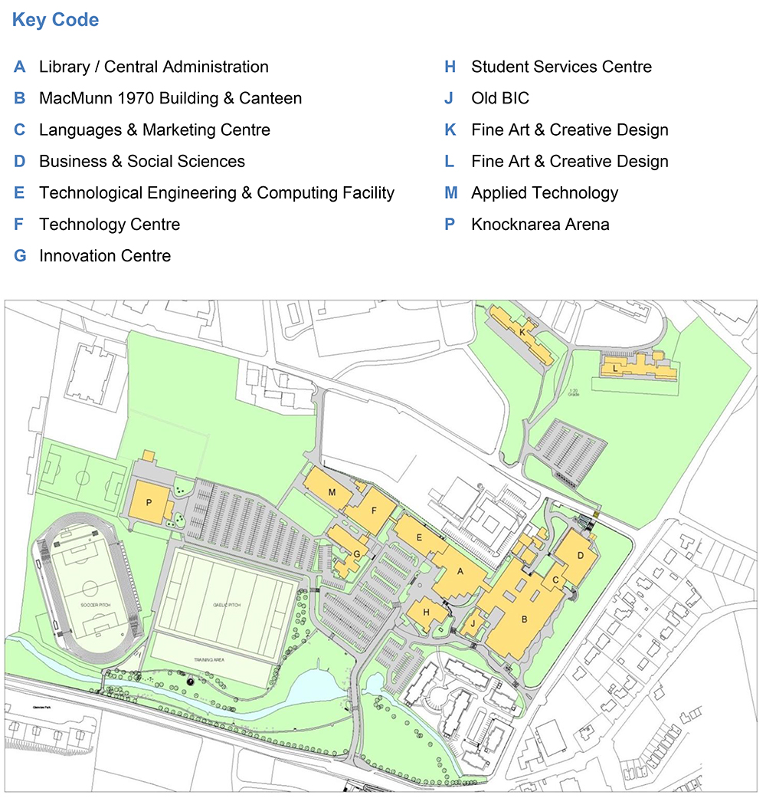

**Transport to Campus**

The IT Sligo campus is located on Ash Lane in Sligo.

**By Car:**

* From Dublin: Follow N4 for Sligo. Continue on N4 through Sligo. Cross Hughes Bridge. Shortly after bridge, take right turn onto N16 (for Enniskillen). IT Sligo is located 400m on left.
* From Galway: Follow N17 for Sligo. At roundabout take N4 for Sligo. Cross Hughes Bridge. Shortly after bridge, take right turn onto N16 (for Enniskillen). IT Sligo is located 400m on left.
* From Letterkenny: Follow N15 for Sligo. Before Hughes Bridge, take left turn onto N16 (for Enniskillen). IT Sligo is located 400m on left.

Google Map Directions [here](https://www.google.com/maps/place/Institute+of+Technology+Sligo/@54.278,-8.46,14z/data=!4m5!3m4!1s0x0:0xc76b5b21d985fb79!8m2!3d54.2785534!4d-8.4600902?hl=en)

**By Train:**

* A train service operates from Dublin’s Connolly Station to Sligo. Timetable [here](http://www.irishrail.ie/media/07_dublin_-sligo.pdf)

**By Bus:**

* Bus Eireann operates the 23 service from Dublin’s Bus Arás to Sligo. Timetable [here](http://www.buseireann.ie/inner.php?id=406&form-view-timetables-from=Charlestown+%28Market+Square+-+Murrays%29&form-view-timetables-to=Galway+%28Bus+Station%29&form-view-timetables-route=23&form-view-timetables-submit=1)
* Bus Eireann operates the 64 service Galway-Sligo-Derry. Timetable [here](http://www.buseireann.ie/inner.php?id=406&form-view-timetables-from=&form-view-timetables-to=Galway+%28Bus+Station%29&form-view-timetables-route=64&form-view-timetables-submit=1)

Sligo’s Train and Bus Stations are located next to each other. Taxis are available. It is a 27 minute walk to IT Sligo campus. Directions [here](https://www.google.com/maps/dir/Sligo+Train+Station,+Knappagh+Road,+Abbeyquarter+North,+Sligo/Institute+of+Technology+Sligo,+Ash+Ln,+Bellanode,+Sligo,+F91+YW50/@54.2745024,-8.4765504,15.78z/data=!4m14!4m13!1m5!1m1!1s0x485ee83216ee8645:0x9af7e659572be848!2m2!1d-8.4818937!2d54.2720255!1m5!1m1!1s0x485ee84ef3fb4b37:0xc76b5b21d985fb79!2m2!1d-8.4600902!2d54.2785534!3e2?hl=en)

* Bus Feda also operates a Donegal-Galway bus service serving Sligo. Timetable [here](https://busfeda.ie/donegal-galway). It is a 20 minute walk from their bus stop. Directions [here](https://www.google.com/maps/dir/Bank+of+Ireland,+Stephen+Street,+Abbeyquarter+North,+Sligo/Institute+of+Technology+Sligo,+Ash+Ln,+Bellanode,+Sligo,+F91+YW50/@54.2741715,-8.472291,16.26z/data=!4m14!4m13!1m5!1m1!1s0x485ee83436c4b34f:0x9fd98e030e723a90!2m2!1d-8.4729367!2d54.2725257!1m5!1m1!1s0x485ee84ef3fb4b37:0xc76b5b21d985fb79!2m2!1d-8.4600902!2d54.2785534!3e2?hl=en)

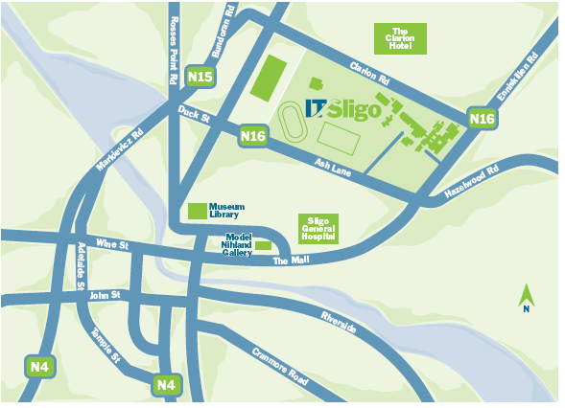

**Accommodation**

You are offered special conference rates at the Glasshouse Hotel, Swan Point, Sligo. <https://www.theglasshouse.ie/>

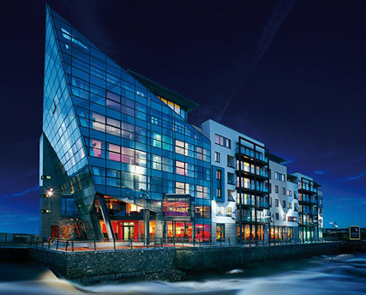

The Bed & Breakfast rates for conference delegates are as follows:

* Thursday 6th September Standard single room €75.00 B&B
* Friday 7th September Standard single room €119.00 B&B
* Saturday 8th September Standard single room €129.00
* Sunday 9th September Standard single room €75.00 B&B

For booking, contact Elaine at: [resmanager@theglasshouse.ie](mailto:resmanager@theglasshouse.ie)

Or phone: [+353 (0)71 919 4300](tel:+353719194300)